Information for US citizens taking Canis Bodyworks courses in Canada
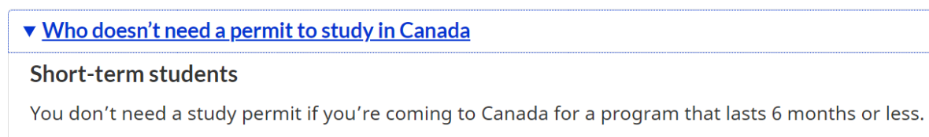
Direct link to Government of Canada page

